|  |
| --- |
| **CDSS Lab Programs** |
| 1a. Program to count the number of characters, words, spaces and lines in a given input file. |
| 1b. Program to recognize and count the number of identifiers in a file. |
| 2a. Program to count the numbers of comment lines in a given C program.Also eliminate  them and copy the resulting program into separate file. |
| 2b. Program to recognize whether a given sentence is simple or compound. |
| 3a. Program to count no of: i.+ve and –ve integers  ii. +ve and –ve fractions |
| 3b. Program to count the no of ‘scan f’ and ‘printf’ statements in a C program. Replace them with ‘readf’ and ‘writef’ statements respectively. |
| 4.Program to evaluate arithmetic expression involving operators +,-,*,/ |
| 5.Program to recognize a valid variable which starts with a letter, followed by any number  of letters or digits. |
| 6. Program to recognize the strings using the grammar (anbn ;n>=0) |
| 7. C Program to implement Pass1 of Assembler |
| 8. C Program to implement Absolute Loader |
| 9. C program to find the FIRST in context free grammar. |
| 10.C Program to implement Shift Reduce Parser for the given grammar E →E+E  E→E*E E→(E)  E → id |
| 11.C Program to implement code optimization techniques. |

# COMPILER DESIGN PROGRAMS:

1. **C Program to implement Pass 1 algorithm of assembler.**

#include<stdio.h> #include<conio.h> #include<string.h> void main(){

FILE *f1,*f2,*f3,*f4; int lc,sa,l,op1,o,len;

char m1[20],la[20],op[20],otp[20]; clrscr();

f1=fopen("input.txt","r");

f3=fopen("symtab.txt","w"); fscanf(f1,"%s %s %d",la,m1,&op1); if(strcmp(m1,"START")==0)

{

sa=op1; lc=sa;

printf("\t%s\t%s\t%d\n",la,m1,op1);

}

else lc=0;

fscanf(f1,"%s %s",la,m1); while(!feof(f1))

{

fscanf(f1,"%s",op); printf("\n%d\t%s\t%s\t%s\n",lc,la,m1,op); if(strcmp(la,"-")!=0)

{

fprintf(f3,"\n%d\t%s\n",lc,la);

}

f2=fopen("optab.txt","r");

fscanf(f2,"%s %d",otp,&o); while(!feof(f2))

{

if(strcmp(m1,otp)==0)

{

lc=lc+3; break;

}

fscanf(f2,"%s %d",otp,&o);

}

fclose(f2); if(strcmp(m1,"WORD")==0)

{

lc=lc+3;

}

else if(strcmp(m1,"RESW")==0)

{

op1=atoi(op); lc=lc+(3*op1);

}

else if(strcmp(m1,"BYTE")==0)

{ if(op[0]=='X')

lc=lc+1; else

{

len=strlen(op)-2; lc=lc+len;}

}

else if(strcmp(m1,"RESB")==0)

{

op1=atoi(op); lc=lc+op1;

}

fscanf(f1,"%s%s",la,m1);

}

if(strcmp(m1,"END")==0)

{

printf("Program length =\n%d",lc-sa);

}

fclose(f1); fclose(f3); getch();

}

|  |  |  |
| --- | --- | --- |
| **Input.txt** |  | |
| COPY | START | 1000 |
| - | LDA | ALPHA |
| - | ADD | ONE |
| - | SUB | TWO |
| - | STA | BETA |
| ALPHA | BYTE | C'KLNCE |
| ONE | RESB | 2 |
| TWO | WORD | 5 |
| BETA | RESW | 1 |
| - | END | - |

|  |  |
| --- | --- |
| **Optab.txt** |  |
| LDA | 00 |
| STA | 23 |
| ADD | 01 |
| SUB | 05 |

Output:

|  |  |
| --- | --- |
| **Symtab.txt** |  |
| 1012 | ALPHA |
| 1017 | ONE |
| 1019 | TWO |
| 1022 | BETA |

|  |  |  |  |
| --- | --- | --- | --- |
| **COPY** | **START** | **1000** |  |
| 1000 | - | LDA | ALPHA |
| 1003 | - | ADD | ONE |
| 1006 | - | SUB | TWO |
| 1009 | - | STA | BETA |
| 1012 | ALPHA | BYTE | C'KLNCE |
| 1017 | ONE | RESB | 2 |
| 1019 | TWO | WORD | 5 |
| 1022 | BETA | RESW | 1 |
| 1025 | - | END | - |
| Program length = 25 |  | | |

1. **C Program to implement Absolute Loader.**

#include<stdio.h> #include<conio.h> #include<string.h> #include<stdlib.h> void main()

{

FILE *fp;

int i,addr1,l,j,staddr1;

char name[10],line[50],name1[10],addr[10],rec[10],ch,staddr[10]; clrscr();

printf("enter program name:" ); scanf("%s",name); fp=fopen("abssrc.txt","r");

fscanf(fp,"%s",line); for(i=2,j=0;i<8,j<6;i++,j++) name1[j]=line[i]; name1[j]='\0';

printf("name from obj. %s\n",name1); if(strcmp(name,name1)==0)

{

do

{

fscanf(fp,"%s",line);

if(line[0]=='T')

{

for(i=2,j=0;i<8,j<6;i++,j++) staddr[j]=line[i]; staddr[j]='\0'; staddr1=atoi(staddr);

i=12;

while(line[i]!='$')

{

if(line[i]!='^')

{

printf("00%d \t %c%c\n", staddr1,line[i],line[i+1]); staddr1++;

i=i+2;

}

else i++;

}

}

else if(line[0]='E') fclose(fp);

}while(!feof(fp));

}

getch();

}

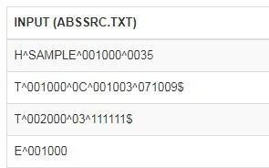

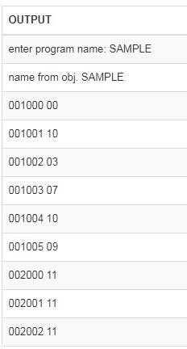

# 9.C program to find the FIRST in context free grammar.

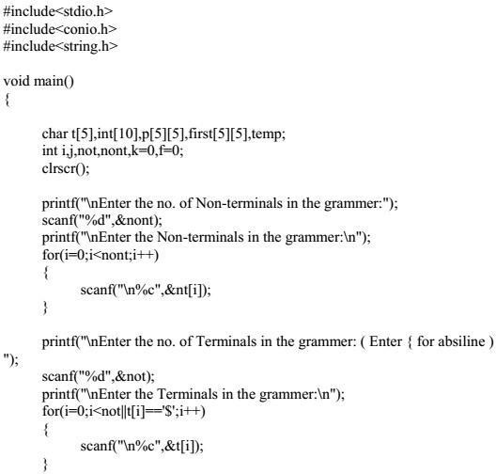

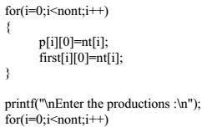

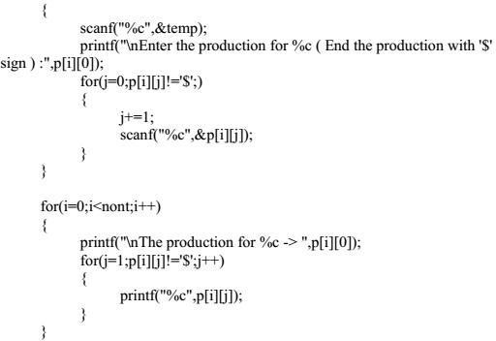

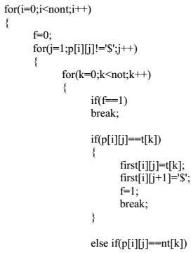

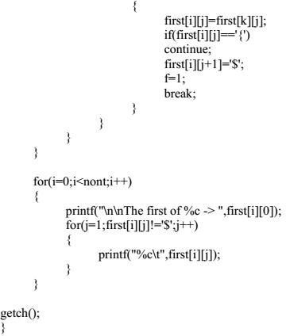

10.C Program to implement Shift Reduce Parser for the given grammar E →E+E

E→E*E E→(E )

E → id #include<stdio.h> #include<conio.h> #include<string.h>

int k=0,z=0,i=0,j=0,c=0;

char a[16],ac[20],stk[15],act[10]; void check();

void main()

{

clrscr();

puts("GRAMMAR is E->E+E \n E->E*E \n E->(E) \n E->id"); puts("enter input string ");

gets(a); c=strlen(a);

strcpy(act,"SHIFT->"); puts("stack \t input \t action"); for(k=0,i=0; j<c; k++,i++,j++)

{

if(a[j]=='i' && a[j+1]=='d')

{

}

else

{

}

}

stk[i]=a[j];

stk[i+1]=a[j+1];

stk[i+2]='\0';

a[j]=' ';

a[j+1]=' ';

printf("\n$%s\t%s$\t%sid",stk,a,act); check();

stk[i]=a[j];

stk[i+1]='\0';

a[j]=' ';

printf("\n$%s\t%s$\t%ssymbols",stk,a,act); check();

getch();

}

void check()

{

strcpy(ac,"REDUCE TO E"); for(z=0; z<c; z++)

if(stk[z]=='i' && stk[z+1]=='d')

{

stk[z]='E';

stk[z+1]='\0'; printf("\n$%s\t%s$\t%s",stk,a,ac); j++;

}

for(z=0; z<c; z++)

if(stk[z]=='E' && stk[z+1]=='+' && stk[z+2]=='E')

{

stk[z]='E';

stk[z+1]='\0';

stk[z+2]='\0'; printf("\n$%s\t%s$\t%s",stk,a,ac); i=i-2;

}

for(z=0; z<c; z++)

if(stk[z]=='E' && stk[z+1]=='*' && stk[z+2]=='E')

{

stk[z]='E';

stk[z+1]='\0';

stk[z+1]='\0'; printf("\n$%s\t%s$\t%s",stk,a,ac); i=i-2;

}

for(z=0; z<c; z++)

if(stk[z]=='(' && stk[z+1]=='E' && stk[z+2]==')')

{

stk[z]='E';

stk[z+1]='\0';

stk[z+1]='\0'; printf("\n$%s\t%s$\t%s",stk,a,ac); i=i-2;

}

}

